

 Hello Solidity – Writing First Smart Contract

**Objective/Aim:**  
  
 To introduce the basics of the Solidity programming language and understand how to write, compile, and deploy a simple smart contract on the Ethereum blockchain.

**Apparatus/Software Used:**

* Laptop
* Solidity (v0.8.x)
* Remix IDE
* Metamask Sepolia testnet wallet

**Theory/Concept:**

**What is a Smart Contract?**

A smart contract is a self-executing program stored on a blockchain. It automatically executes and enforces rules written into its code when certain conditions are met . Here we have use Solidity because we are using Ethereum blockchain to deploy the smart contract .

**What is solidity?**

Solidity is the programming language used to write smart contracts on the Ethereum blockchain.



**Procedure:**

|  |  |  |  |
| --- | --- | --- | --- |
|  |  |  |  |
|  |  |  |  |
|  |  |  |  |
|  |  |  |  |
|  |  |  |  |
|  |  |  |  |
|  |  |  |  |

**Step 1: Open Remix IDE on your browser**

**Step 2: Create a new file give the name of the file then add “.sol” for write the code in solidity**

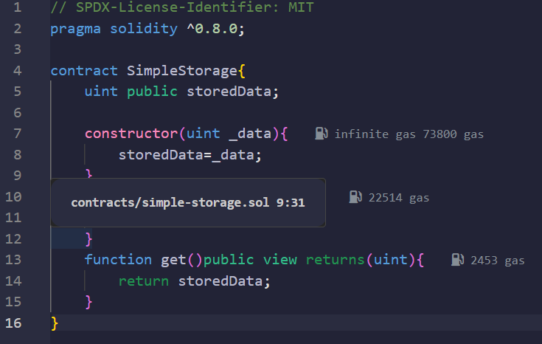**Step 3: Then write the code for the simple storage system**

**Step 4: Go to solidity compiler and compile the code**

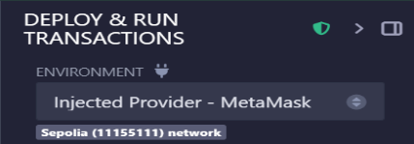**Step 5: Go to the deploy and run section , set the environment as injected provider and connected the wallet enter any data and deploy the transaction**

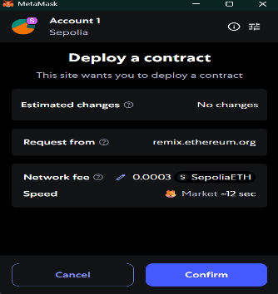**Step 6: Confirm the transaction and the first smart contract have been deployed**

**Observation Table:**

Our first solidity smart contract deployed .



